Example00007
Outcomes Engine REPORTS Program | Approved
Outcomes Engine REPORTS Round | $50,000 Requested  $50,000.00 Allocated
Best applications | 31/03/2021 - 31/03/2022

Healthy Living Communities Inc
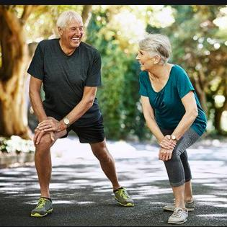
ABN
Healthy Living Communities Inc
Running Social
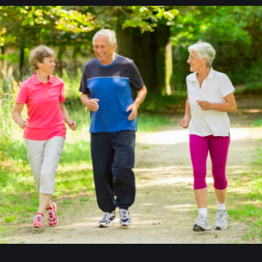
Seniors getting active
This project aims to improve the fitness and social connectedness of people aged 50-64 in the city of Bendigo through a social running program

Outcomes
Health and wellbeing > Improved physical health
Improve the physical fitness of participants (Medium-term)  Alignment: The running social program will improve the physical health of participants through a Couch to 5km program. At the end of the program, participants will be able to run 5km without stopping and will have learned healthy lifestyle habits and built social connections which will endure after the program has finished,  Progress Notes: Participants are already reporting health benefits of regular exercise | Positive shift
Health and wellbeing > Improved mental health
Improve Mental wellbeing of participants (Medium-term)  Alignment: The running social program will help participants to build social connections which will endure after the program has finished. This will improve their mental health  Progress Notes: Participants are forming friendships and becoming less socially isolated | Positive shift

Grantmaker Metrics
 | Target | Progress
Health and wellbeing > Improved physical health
Number of people engaged in sport and recreation activities funded by Goodtown Council grant  Collection: Headcount | 100 | 75
Health and wellbeing > Improved mental health
Percentage of people surveyed who report an increase in confidence or self-esteem as a result of a program funded by a Goodtown Council grant  Collection: Survey administered to participants | 65 | 63

Qualitative Evidence
Case study
Results: Joe, Bill and Darryl were all previously very socially isolated and suffering from poor health. Thanks to our program they are improving their fitness and have become great friends.
Notes: We will profile some participants who have achieved good outcomes both in physical and mental outcomes
Media appearance
Results: Sunrise came to one of our sessions and did a story on our program.
Notes: The project will be featured in local newspapers.

Activities
 | Start Date | End Date | Status
Walk to Run Sessions | 23/03/2021 | 28/02/2022 | Completed (fully)
Social Run / Walk to Run Sessions | 23/03/2021 | 28/02/2022 | Completed (fully)
Initial Project launch event | 22/03/2021 | 23/03/2021 | Completed (fully)
Final results testing - followed by celebration with friends and family | 15/03/2022 | 15/03/2022 | Completed (fully)

Milestones
 | Start Date | End Date | Status
Recruit project workers | 08/02/2021 | 15/02/2021 | Completed (fully)
Write up individual training plans | 18/02/2021 | 22/02/2021 | Completed (fully)
Secure training venues and schedule social events | 23/02/2021 |  | Completed (fully)
Recruit participants | 18/02/2021 | 22/02/2021 | Completed (fully)

Unintended Outcomes
One participant tripped over a hazard and broke his wrist. (Immediate)

Lessons Learnt
Through this project we provided yet further evidence of the importance of exercise and social inclusion to good physical and mental health outcomes.

Most Significant Change
Participants have built new healthy habits new friendships for life

